LEP – Sub Committee

LEP - Lancashire Skills and Employment Board

Private and Confidential: NO

Date: Wednesday, 3 April 2019

Lancashire Digital Skills Partnership - Progress Report

Report Author: Kerry L. O. Harrison, Digital Skills Coordinator,
Kerry.harrison@lancashirelep.co.uk

Executive Summary

The paper provides an overview of the development of the Lancashire Digital Skills Partnership, which was launched in April last year. The Digital Skills Coordinator was appointed in November, and the Network Groups established which link to the Digital Skills Partnership Steering Group.
The paper also provides an overview of example activities aligned with each of the strategic themes of the Lancashire Skills and Employment Strategic Framework – Future Workforce, Skilled and Productive Workforce, Inclusive Workforce and Informed Approach.
Recommendation
The Board is asked to note the update.

  - Background

  - In the Digital Strategy, published in March 2017, the Government set out its commitment to improving the digital skills capabilities of individuals and organisations across England. It was recognised that a partnership approach was required to drive up digital skills. As a result the Government announced the formation of a National Digital Skills Partnership, bringing together public, private and charity sectors and key regional stakeholders to develop a more collaborative, coordinated and innovative approach to meeting the digital skills challenge.

  - The Industrial Strategy, published in November 2017, referenced the establishment of Local Digital Skills Partnerships to increase collaboration between public, private and charity sector organisations and help address local digital skills needs in more targeted and innovative ways in local areas.

  - The Department for Digital, Culture, Media and Sport has established the National Digital Skills Partnership, and is leading on supporting the development of pilot Local Digital Skills Partnerships across the country which are focused on local partners coming together to look at how best to tackle local digital skills needs across the spectrum.

  - Lancashire had already identified a need for action across the digital skills agenda and had started to embed this in to the Lancashire Skills and Employment Strategic Framework. This strategic planning and linked activity fundamentally lead to the successful bid to be a Local Digital Skills Partnerships pilot. The Lancashire Partnersip the first pilot to be launched at the Lancashire Digital Skills Summit, held at EKM in Preston, in April 2018. The Department for Digital, Culture, Media and Sport awarded a grant of £75k to enable the appointment of a Digital Skills Partnership Coordinator for 12 months, associated costs and funds for events. The Coordinator will drive activity locally and also meet regularly with the Department for Digital, Culture, Media and Sport and Coordinators from other areas to support the roll out of Local Digital Skills Partnerships across the Country. Kerry Harrison was appointed to the Coordinator role and commenced employment in November 2019.

1.5 Since the launch, two further pilots have been launched in the West Midlands
and the Heart of the South West. A further 3 Local Digital Skills Partnerships will be formally announced in the coming months; Cornwall and the Isles of Scilly will launch first at the Eden Project on Thursday 25th May, 2019, Cheshire and Warrington in June and the South-East in July 2019.

2.0 Department for Digital, Culture, Media and Sport and Local Digital Skills Partnerships support
2.1 Support mechanisms from the Department for Digital, Culture, Media and Sport for Regional Coordinators have developed to include weekly phone calls and monthly face to face meetings at Whitehall. The meetings provide opportunity to share good practice and lessons learnt with other Local Digital Skills Partnerships.
2.2 Regular blogs are now scheduled to be published on the DSP website starting with an introduction to the Regional Coordinators: https://digitalskillspartnership.blog.gov.uk/2019/02/26/introducing-the-dsps-regional-coordinators-kerry-harrison-lancashire/ and a follow up blog on the work of the Lancashire DSP with National Partners: https://digitalskillspartnership.blog.gov.uk/2019/03/06/the-work-of-lancashires-digital-skills-partnership/. A Lancashire focused Freeformers blog being jointly written by Laura Myers - Lancashire Adult Learning, Kerry Harrison and Freeformers will also be published shortly.
2.3 A new DSP logo has been produced and can be used on marketing materials and by all partners.

2.4 Lancashire are one of only 4 areas in the Country to successfully secure Digital Skills Innovation Fund (DSIF). Lancashire has been allocated £261,000 towards Digital Skills projects which will support unemployed into digital roles and support self-employed females and females in the workplace to develop their digital skills.

Official announcement of the fund was made on Friday 15th March: https://www.gov.uk/government/news/coding-to-be-taught-in-prison-to-help-offenders-return-to-the-world-of-work & http://www.thebusinessdesk.com/northwest/news/2038734-lancashire-wins-share-of-digital-skills-funding-from-government

2.5 A number of introductions have been made by the DCMS and DSP that have
been followed up accordingly - these include: MyBank, The Business Café,
Tech Talent Charter, Tech North Advocates, Office for Civil Society, Founders4Schools, Lloyds, Google, Good Things Foundation, Freeformers, Code First Girls, Devon County Council, OneDigital. Work is underway to consider the range of activities that are available and how these could add value to activity already in place locally.

2.6 Kerry Harrison was invited to present the National DSP ‘Asks’ to the Digital
Enterprise Delivery Group chaired by Mark Temple from Lloyds. Mark is trying to promote greater links between the LDSPs and his group. From this a number of introductions were made including OneDigital and also CISCO who offered an industry day visit to their Idea Centre in Manchester.

- Steering Group and Networking Groups

- As per the update provided at the last formal committee meeting, a Steering Group for the Partnership has been established, chaired by Mike Blackburn, LEP Board Director. A key task has been to establish the networking groups to enable broader stakeholder engagement in the partnership. Figure 1 provides an overview of the model.

- The Future Networking Group and Skilled and Productive Workforce Networking Groups launched at the end of January. Both were well attended and feedback was positive, for example: "everyone round the table seems on board, listening to the issues faced by the different areas; useful network/partnership; good to learn about initiatives happening currently and aspirations for the group; great to meet people, hear about initiatives and the journey so far".

- The Networking Groups agreed to meet quarterly and will rotate location around the County allowing opportunities to show case locations such as Strawberry Fields, Chorley.

- The Inclusive Workforce Networking Group sits within the Adult Skills Forum. As a result, this group has met more frequently with a meeting in January and March, following an introduction in November.

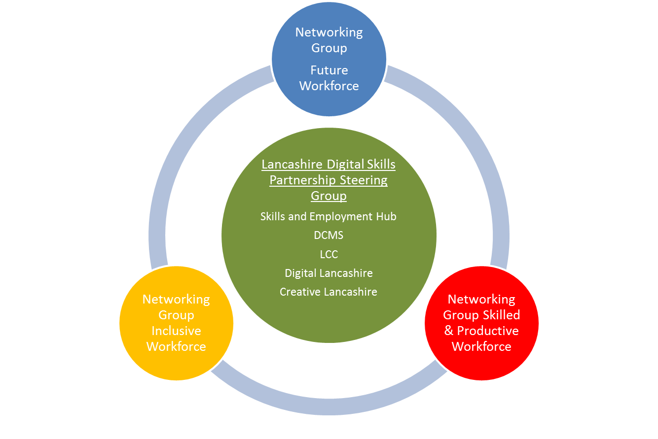
Figure 1 – Structure of the Lancashire Digital Skills Partnership

4.0 Activity aligned with the Strategic Themes

The following provides an insight into examples of activities, aligned with each of the strategic themes.

- Future Workforce

  - Sixty Year 9 pupils from Blackpool secondary schools attended the Lloyds Rediscover event, which included 10 pupils from each of the following schools: Aspire Academy; Montgomery High School; St George’s High School St Mary’s RC Academy; South Shore Academy, and Unity Academy. Feedback from the pupils involved was excellent. Further discussion has been had with Lloyds regarding rolling out events across Lancashire and developing a sustainable model for the future.

  - Technical Education development activity has had a focus on Digital with the Teach Too project, secured and delivered in collaboration with The Lancashire Colleges (TLC). The project involved digital employers providing masterclasses and industry days to tutors and teachers from across Lancashire. The project has exceeded targets, reaching 33 employers and over 180 college staff. An evaluation of the project is currently in production.

  - Chorley Hack Event – a very successful event was run at Chorley Town Hall with 30 primary and secondary schools working with local employer mentors and a National DSP partner (AWS) to code something to educate on Cyber-security or Online bullying. BOOST and the LDSP supported this event; BOOST provided a prize (iPad) and Kerry Harrison was a judge. Shaheen Gul, Enterprise Coordinator for the area, linked employers to be mentors during the event and built the event into careers plans with the secondary schools.

  - IDea - Duke of York Awards - we introduced the iDea Awards scheme to the Networking groups. The iDea Awards enables individuals to develop their digital skills through bite-size on-line learning and the achievement of badges. We have worked with the office at Buckingham Palace to create a Lancashire badge which allows tracking of involvement across Lancashire – details below:

Badge Name Digital Skills Lancashire 18+, Badge Code: D1G1LANCS18UP.
Badge Name: Digital Skills Lancashire Under 18, Badge Code: D1G1LANCS18UN

- Skilled and Productive Workforce

  - Google Garage - over 600 people from SMEs across Lancashire have attended workshops, a second round of training is now being offered with partners, including Economic Development Officers in the Local Authorities, to fully utilise the offer of 1000 training places from Google. March and April will see more courses - 6 are planned so far.

  - Whilst the initial training has been warmly received by the employers involved, there is a need to consider follow up and progression from the Google Garage events (beyond being signposted to the Google Garage in Manchester, which is due to close on the 13th April). Work is underway with Lloyds who have responded to the SME feedback on the Google Garage training; Lloyds are developing two programmes for SMEs. The first is branded 'Digital Know How' Workshops. The first session is in planning for April, and is likely to be held at The Landmark in Burnley. The second Lloyds programme is likely to be a staged programme of learning over 5 months.

  - DTS learndirect have also set up Skills Support for the Workforce (SSW) courses designed to be next steps for SMEs who may have completed Google Garage Training. They are running 6 face to face sessions across the county on Digital Marketing and an online offer.

- Inclusive Workforce

  - Freeformers/Facebook training is being delivered by Lancashire Adult Learning and Blackpool and Fylde College to millennials. Feedback is positive from this training.

  - We are in talks with Lancaster and Morecambe College about offering the Freeformers training in the North of the County. We are also investigating whether this training could feature at The Festival of Making and are in liaison with Ed Matthews-Gentle, Senior Projects Officer, Business Growth.

  - IDea - Duke of York Awards – was introduced. This scheme has been introduced in Wigan to adult learners and as a result digital exclusion in Wigan has reduced from a medium risk to a low risk. The Awards scheme is complementary to the provision currently delivered through ESF and mainstream funding.

- Informed Approach

Research regarding digital skills in Lancashire is currently being commissioned, to enable the sector study produced in 2015/16 to be refreshed and expanded, so that it is complementary to the strategic themes in the Lancashire Skills and Employment Strategic Framework. ESF funding, DCMS funding and funds from Digital Lancashire are supporting the commission.

List of Background Papers

Paper | Date | Contact/Tel
N/A

Reason for inclusion in Part II, if appropriate

N/A

